**DUE DATE & VALIDATION TEST: Monday 29th October 2018**

* ***SHOW ALL WORKING TO RECEIVE FULL MARKS***
* ***DO NOT WRITE YOUR ANSWERS ON THIS SHEET***

1. The pedigree below shows the inheritance, within a family, of the ***X-linked characteristic*** known as red-green colour blindness. Shaded individuals possess the characteristic. Individual 11 is a baby and it has not yet been determined if she is affected.

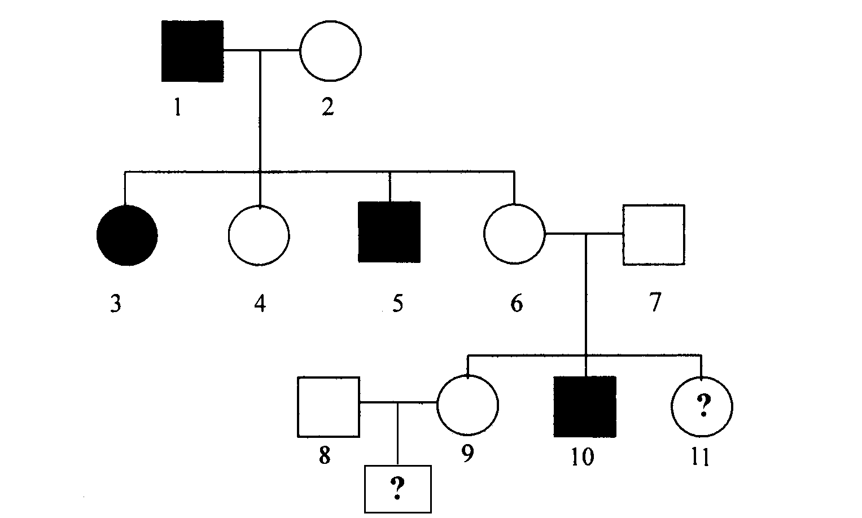

* 1. Using the symbol *R* to represent the dominant allele and *r* for the recessive allele:  
     1. What is the genotype of individual 2?
     2. What is the genotype of individual 6?

(2 marks)

* 1. What is the probability that newborn daughter 11 will be  
     1. Red-green colour blind?
     2. A carrier of the gene?

(4 marks)

* 1. If daughter 9 has a son by her unaffected husband, what is the probability that this son will be red-green colour blind?

(3 marks)

1. The following Pedigree shows the inheritance of the disease Phenylketonuria (PKU) in a particular family.



* 1. What is the genotype of the following individuals shown in the pedigree chart above? I 2, II 2, III 5 and IV 2.

(4 marks)

* 1. Female IV 1 is pregnant. The father of the child is normal and has no history of PKU in his family. Is it possible for her to have a PKU child? Explain. (4 marks)

1. The pedigree below shows the inheritance, within the family, of a very rare disorder. Individual IV.3 is a newborn baby who has not yet been tested for the disorder.

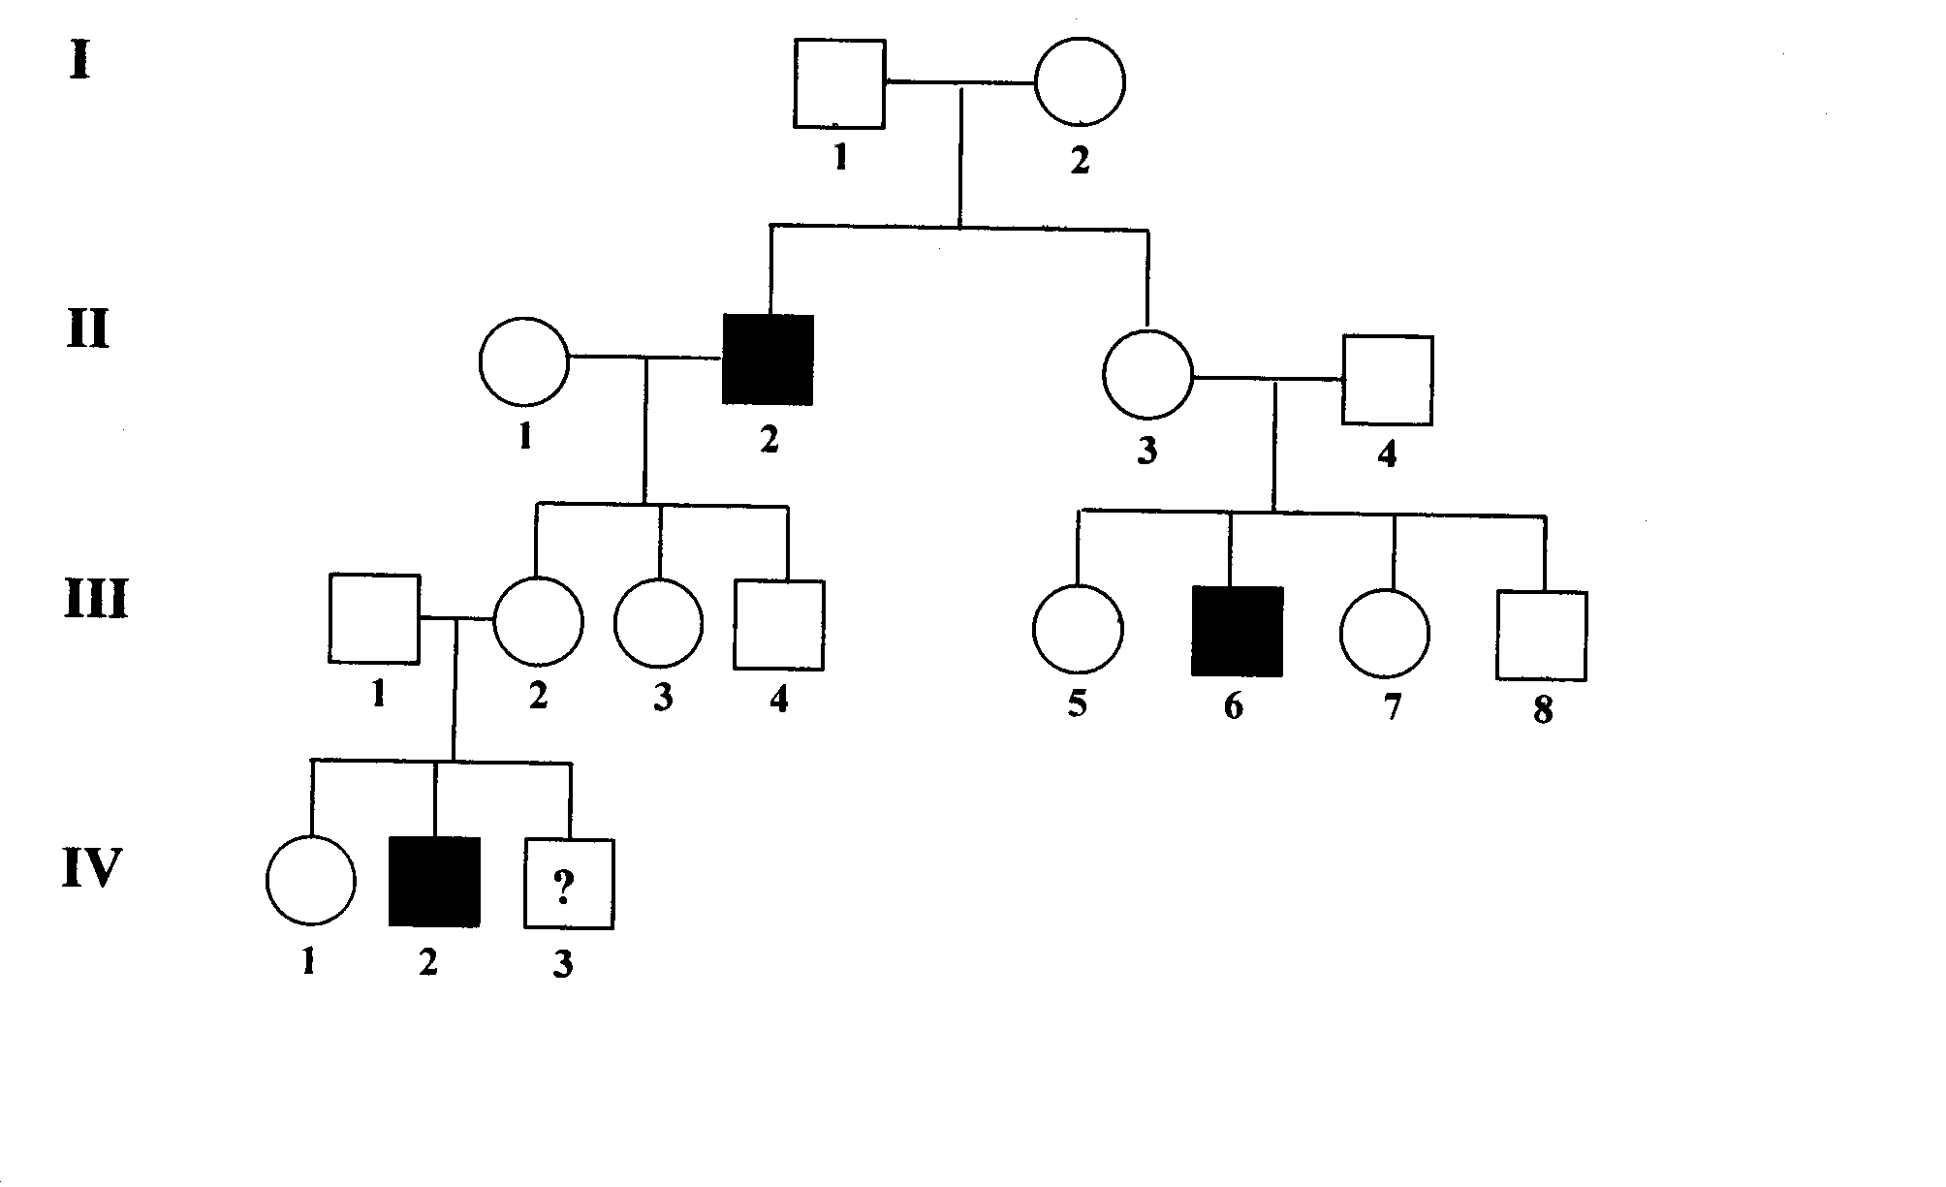

* 1. Is the disorder inherited as a dominant or recessive trait? (1 mark)
  2. Explain how you arrived at your answer in (a) (1 mark)
  3. Is the trait **more likely** to be autosomal or X-linked? (1 mark)
  4. Explain how you arrived at your answer in (c). (1 mark)
  5. Using the letters *A* and *a* to represent dominant and recessive alleles, respectively, write the full genotype of individual I.2. (1 mark)
  6. What is the probability that the newborn baby (individual IV.3) has the disorder? (3marks)

1. The following Pedigree shows the inheritance of the disease Duchenne Muscular Dystrophy



1. What is Duchenne muscular dystrophy? (2 marks)
2. Is Ducehnne Muscular Dystrophy autosomal dominant, autosomal recessive or sex-linked recessive? (1 mark)
3. Why doesn't Duchenne Muscular Dystrophy occur in girls? (1 mark)
4. Write down the symbols for a dominant trait and a recessive trait. (1 mark)
5. What are the genotypes and phenotypes for I 1, II 1, III 5, IV 4 (4 marks)
6. III 11 is pregnant what is the probability that she is carrying another son with muscular dystrophy? Show your working. (4 marks)
7. Tongue rolling is dominant to non-tongue rolling. A man who can roll his tongue, has children with a woman who can also roll her tongue. They produce two children who cannot roll their tongue.
   1. What is the chance that they produce a child who can roll their tongue?

(3 marks)

* 1. If they were to have another child, what is the chance they have boy who cannot roll his tongue? Show your working

(4 marks)

1. Draw a correct pedigree from the following information, using the initial letters of the names of the people involved (eg 'N' for Norman).

Alan is married to Beatrice. They have five children born in the following order, Cheryl, Douglas, Edward, Frederick and George. Sadly, Frederick died as a baby. Cheryl is married to Henry and George is married to Isabelle. Cheryl and Henry have two daughters, Julie (eldest) and Kate. Leonard and Martin are brothers. Their mother is Isabelle.

(3 marks)

1. The pedigree below shows the inheritance, within a family, of a very rare disorder called Gingus Rangus Monobrowii where the affected individual has red hair and only one eyebrow.

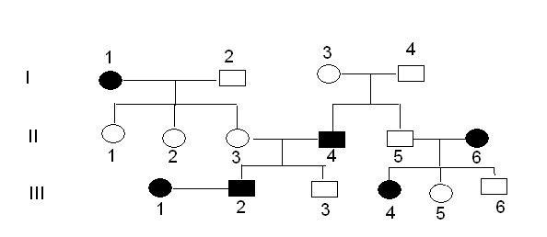

* 1. Is the disorder inherited as a dominant or recessive trait? (1 mark)
  2. Explain how you arrived at your answer in (a) (1 mark)
  3. Is the trait autosomal or X-linked? (1 mark)
  4. Explain how you arrived at your answer in (c). (1 mark)
  5. Using R and r what are the genotypes of the following individuals
     1. I.2
     2. I.3
     3. II.3
     4. II.4
     5. II.5
     6. III.3 (3 marks)

1. You are a Genetic Counsellor Harry and Mary Wilson have come to you concerned about the risk of having a child affected by the inherited disease cystic fibrosis. Mary’s sister, Lily, has just had a daughter (Alicia) who has been diagnosed with the disease.
2. How is cystic fibrosis inherited? (2 marks)
3. They have brought incomplete pedigrees for each of their families. Use the information provided to redraw the pedigrees and add to them. (3 marks)

* ***William died of cystic fibrosis***
* ***Matthew has married Tina and they have a daughter called Candy***
* ***Barbara’s mother (who is dead) is Karen and her father is called John. Barbara was an only child***

1. Show the members of this family who are **definitely** carriers, by adding dots to their circle or square. (1 mark)
2. What is the probability of Mary being a carrier if Mary’s mother is not carrying the disease? (3 marks)
3. This disease has never occurred in Harry’s family. Does this mean Harry can’t be carrying the disease? Explain your answer. (2 marks)
4. How can Harry and Mary confirm whether they are carriers? (1 mark)
5. What is the probability of them having a child with the disease if:
   * 1. both are carriers?
     2. Mary is a carrier and Harry is not a carrier?
     3. neither is a carrier? (3 marks)

**Mary’s family**

Andrew Agnes

Margaret Alan Angela William Horace Barbara

Kris Lily David George Mary

Zach Alicia

**Harry’s family**

Paul Elizabeth

Henry Jane Beth Carlos Helen Matthew

Harry Deanna Jack Miguel Fernando

***END OF TASK: TOTAL MARKS: 70***